# Anexo 4 - Fase 4 y 5 - Modelamiento y Evaluación

## Modelos entrenados

CI num_cap

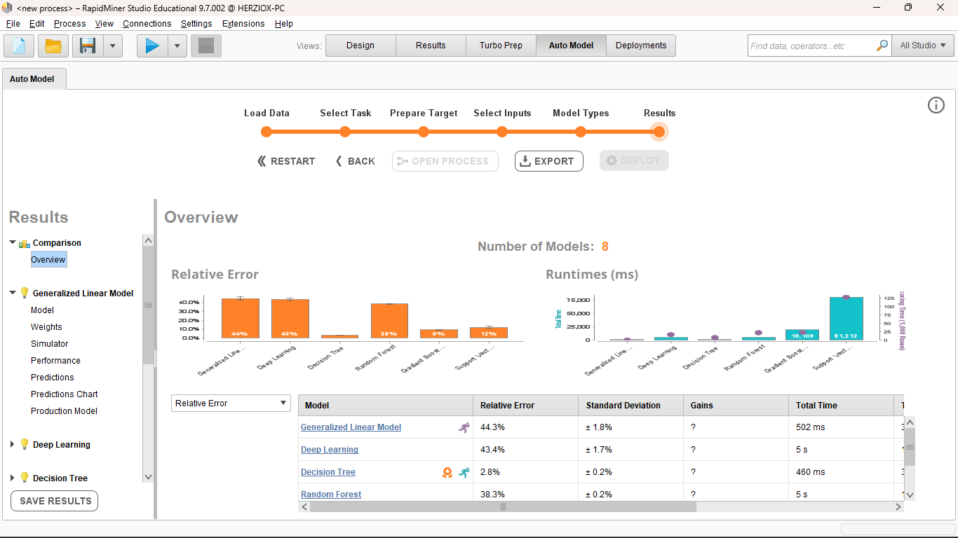

CI total_horas

CI Total_ganancias

CI volumen_Cap

CI volumen_horas

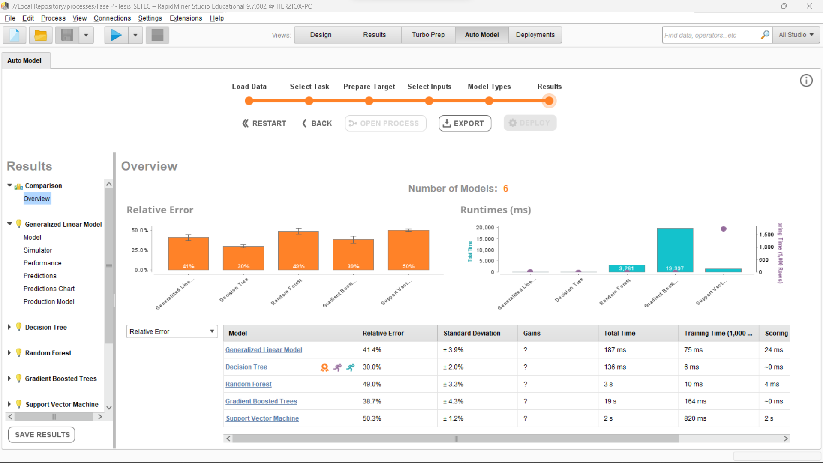

CI volumen_ganancias

CI Total_cursos

OC num_cap_cer

OC total_horas

OC Total_Ganacias

OC porcentaje_asistencia

OC Volumen_cap_cer

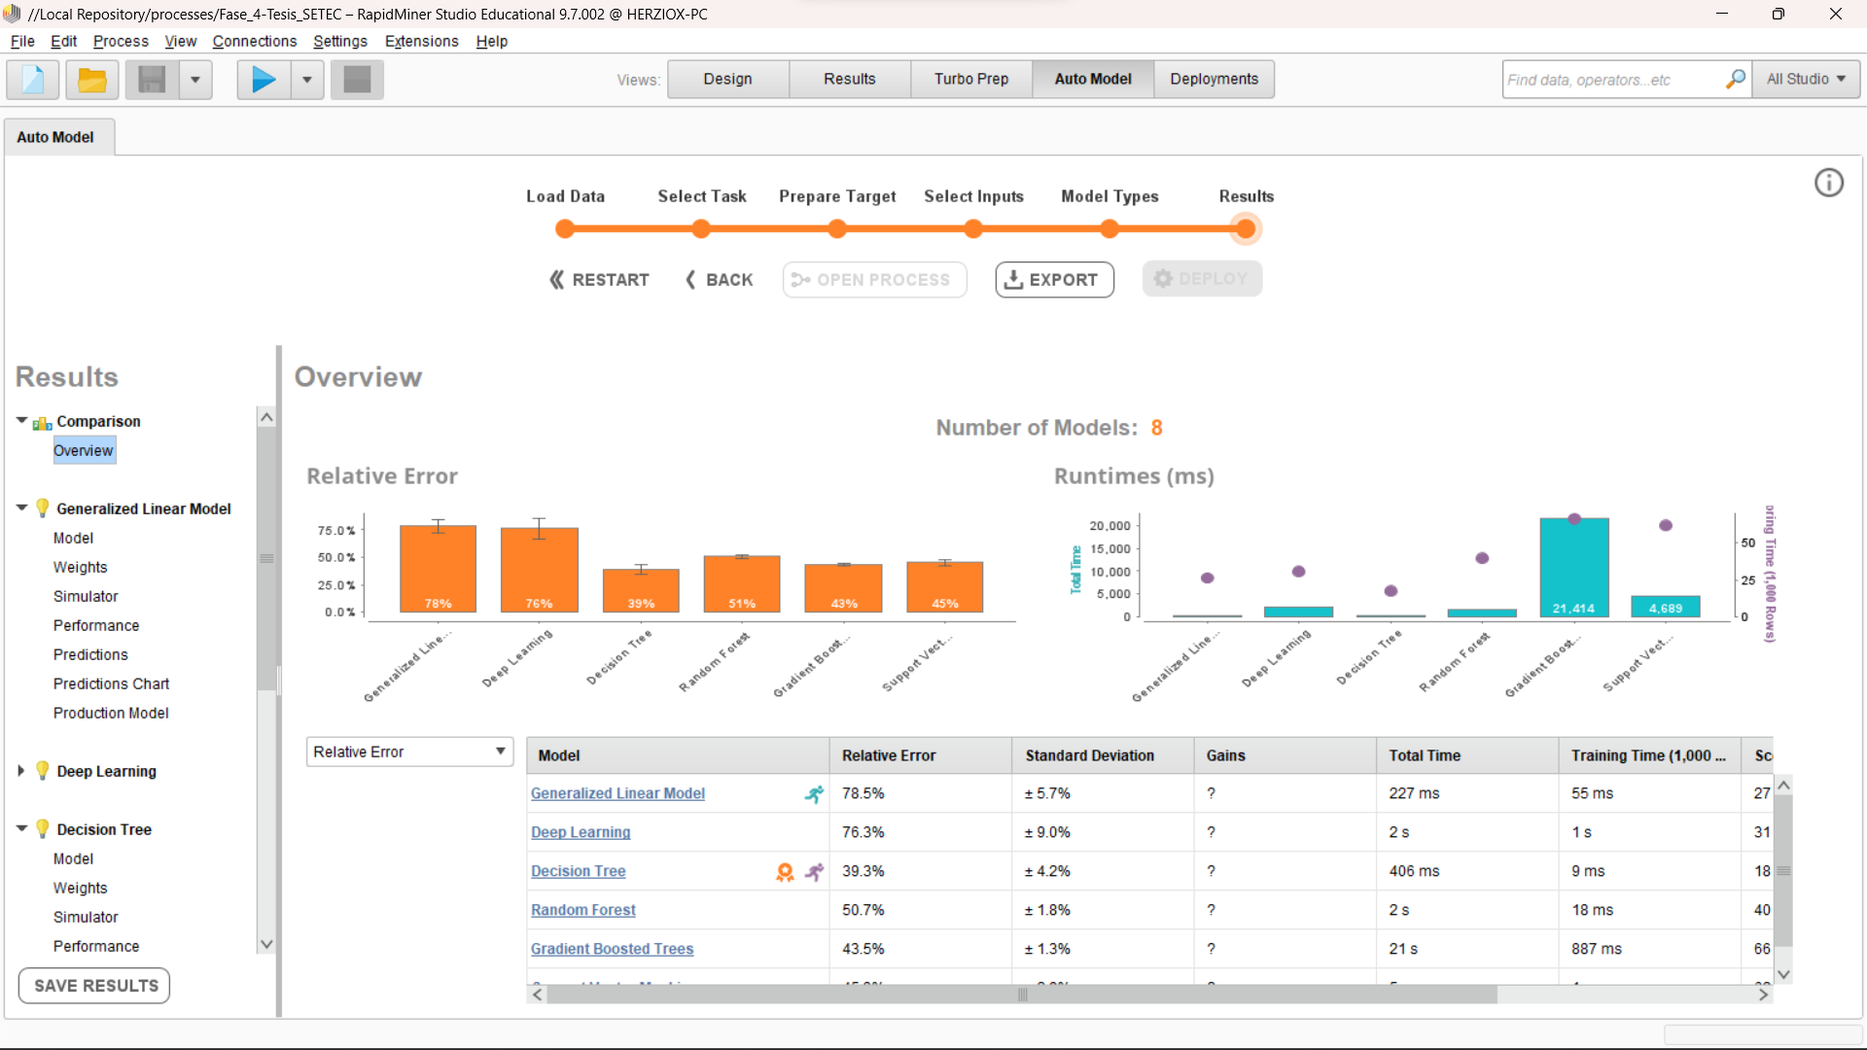

OC volumen_horas

OC volumen_ganancias

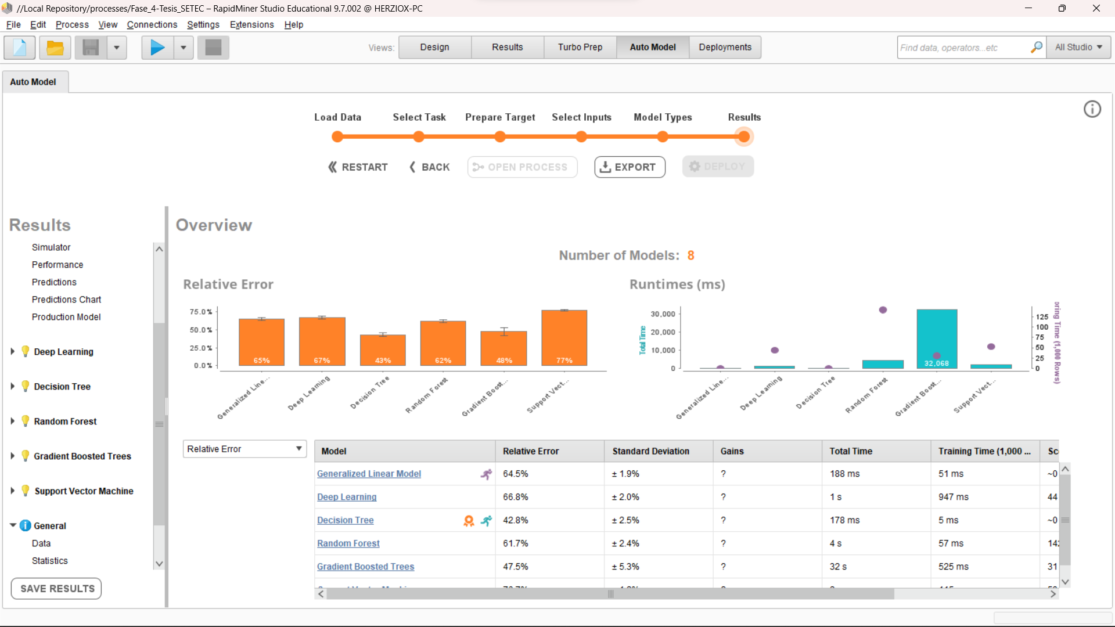

OC total_cursos

OC volumen_porcentaje_asistencia

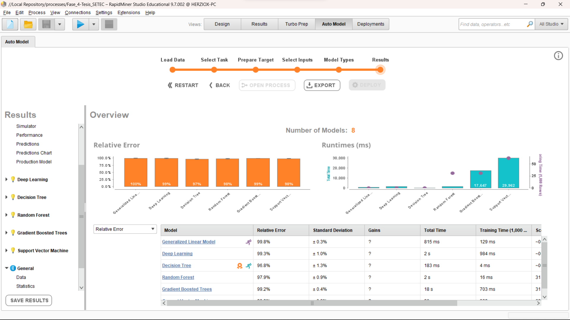

OEC num_cer

OEC total_horas

OEC total_gananias

OEC porcentaje_asistencia

OEC volumen_cer

OEC volumen_horas

OEC volumen_ganancias

OEC total_perfiles

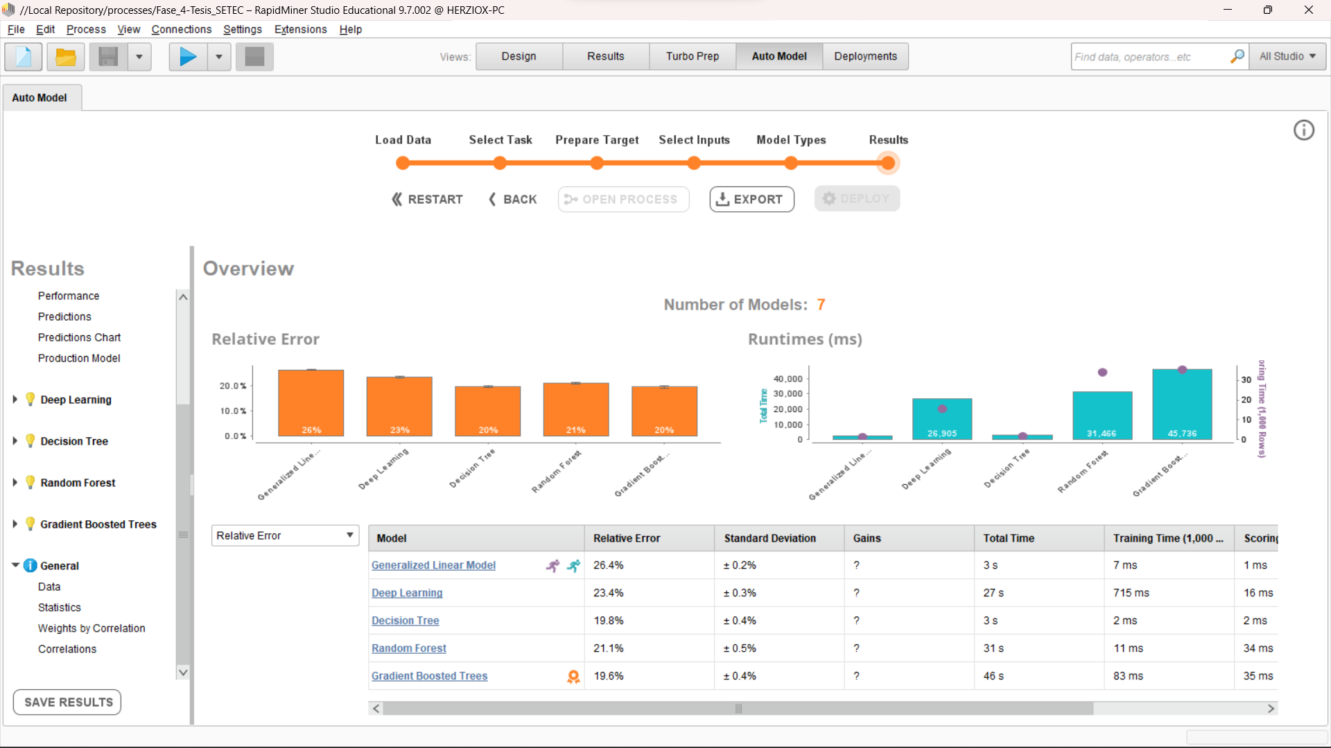

OEC volumen_porcentaje_asistencia

## Conexión con MySQL

Para tener un seguimiento y respaldo de los modelos se utilizó el DBMS MySQL para conectar con RapidMiner cómo se muestra a continuación.



